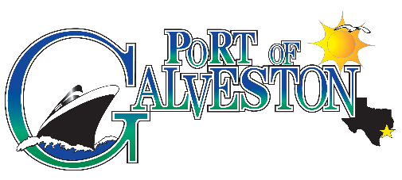

AAPA COMMUNICATIONS AWARDS PROGRAM

  - Port of Galveston
  - 2017 Community open house
Classification: Special Events
Port Category: 2

Summary:
The 2017 Community Open House was coordinated in an effort to inform, educate, and engage the public to meet and mingle with port staff, staff of port tenants and other maritime organizations. Additionally, it gave the port an opportunity to showcase its newly renovated cruise terminal to the general public by giving tours of the facility and educating them on cruise operations.

What are/were the entry’s specific communications challenges or opportunities?
The Community Open House was an opportunity to educate, inform and engage the public to meet port staff, staff of port tenants, and members of several maritime organizations.
There was staff on-hand to give tours of the cruise terminal and answer questions about the facility. In addition to tours of the building, several port tenants had exhibits showcasing their businesses and operations. Members of the community were able to browse exhibits about port operations, meet various maritime professionals and learn about the wide variety of activity that takes place at the Port of Galveston’s wharves.

How does the communication used in this entry complement the organization’s overall mission?
The Port’s Mission is elaborated as: “Port of Galveston management and staff will protect, preserve and enhance the assets of the City of Galveston’s waterfront property by continuing to rebuild and improve facilities to grow opportunities for existing customers and attract new businesses that will promote jobs and economic prosperity for the community.
Port of Galveston management and staff fully recognize the value of Port property in a global economy and will continue to seek alternative sources of funding and development arrangements to expand and diversify the Port’s commercial base with accountability and sensitivity to Port and community stakeholders.”
The primary goal of the community open house was to inform, educate and engage the public in order to raise awareness and to generate interest in the community about the Port and its businesses. In line with the Port’s Mission Statement, the businesses that exhibited demonstrated the job creation and economic impact the Port is providing to the community.

What were the communications planning and programming components used for this entry?
The primary goal of the community open house was to inform, educate and engage the public in order to raise awareness and to generate interest in the community about the Port and its businesses. Additionally, it gave us the opportunity to showcase the newly renovated cruise terminal 2.

The goal was to attract a minimum of 150 attendees and a minimum of 15 business to exhibit at the event.

The planning committee worked with port engineering team to allocate space for 20 booth spaces (6 ft table and 2 chairs) and eight -10 person tables with seating. A diagram was drawn, printed and given to attendees with information about exhibitors and their booth locations, as well as restrooms, refreshment stand, photo booth etc.

Port staff created an invitation to be handed out to the public (local organizations, tenants, schools, social clubs etc.). Invitation was posted in the local newspaper, community bulletin and several e mail blasts. In addition, staff created a Facebook event inviting everyone on social media to the event and to promote the open house before and during the event. Reminders were sent out that reached thousands of social media users.

Port staff created a budget to purchase refreshments (hotdogs, chips, sodas, cake,) for exhibitors and attendees. A refreshment area was designated and manned by staff members and a seating area was arranged for attendees that accommodated up to 80 people. In addition, a section of the terminal was reserved for a group of staff members to give tours of the recently renovated cruise terminal and educate on cruise operations.

Port staff created a photo booth with a table of several props and 2 custom frames that read #2017POGCOMMUNITYOPENHOUSE to be shared on Facebook and followed on Twitter.

Port staff followed up with a thank you letter to all participants with links to event photos.

What were the communications outcomes from this entry and what evaluation methods were used to assess them?
Attendance of both members of the community and exhibitors exceeded expectations. Approximately 300 people attended (sign in sheet & counter) and 25 maritime businesses had a table or booth at the event. When meeting with attendees all comments were favorable, with many asking if there would be an event in 2018.
Favorable comments from various attendees and participants were mentioned in an article published in Galveston Daily News titled, “Area Leaders Praise Port’s First Open House”.
Link: http://www.galvnews.com/news/article_3bc118d2-3813-558d-8203-0b16ecfdf542.html
INVITATIONS
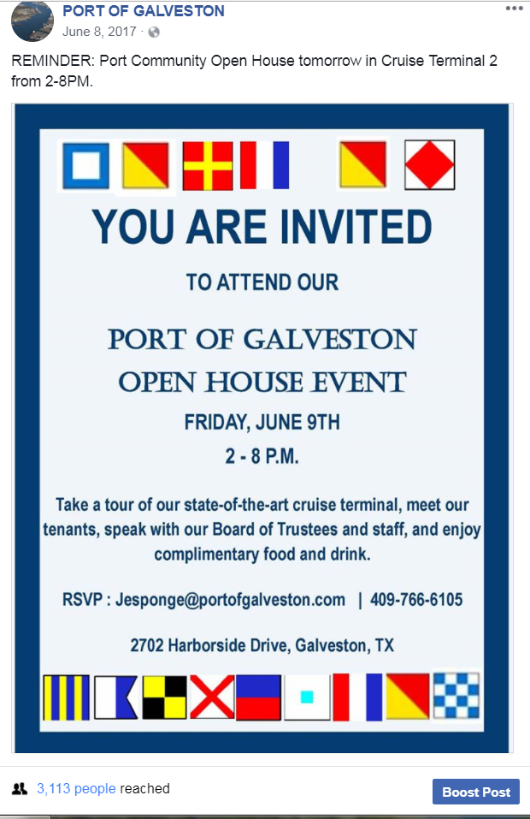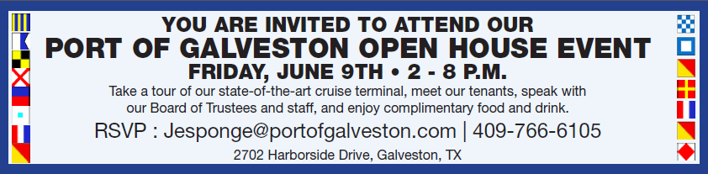
Flyer Newspaper Invitation
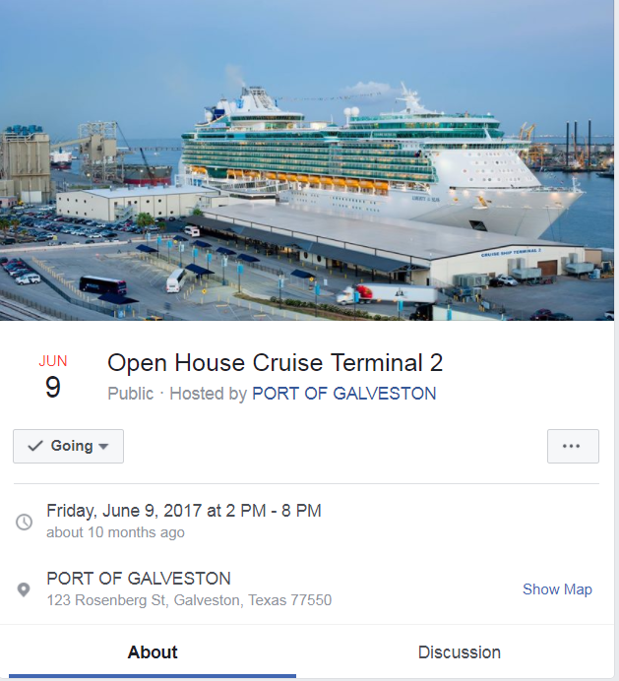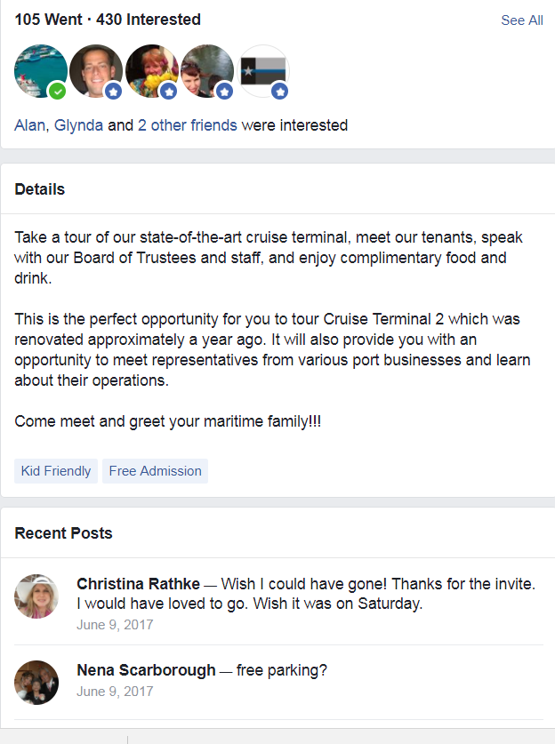
Facebook Event Facebook Invitation

k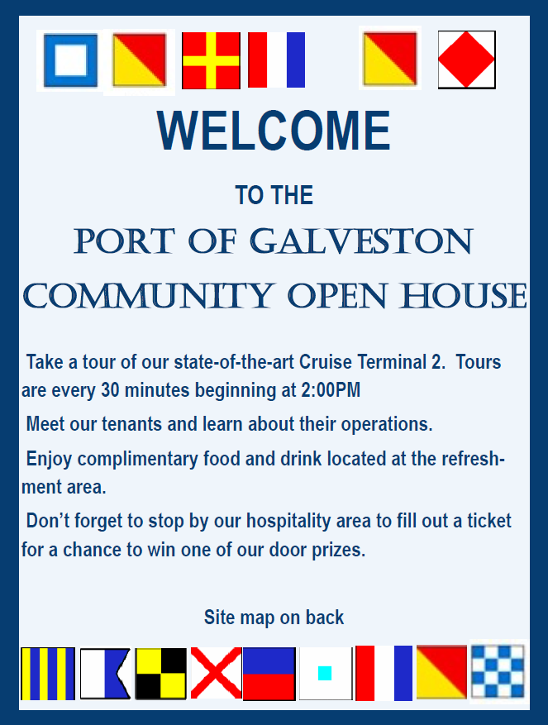 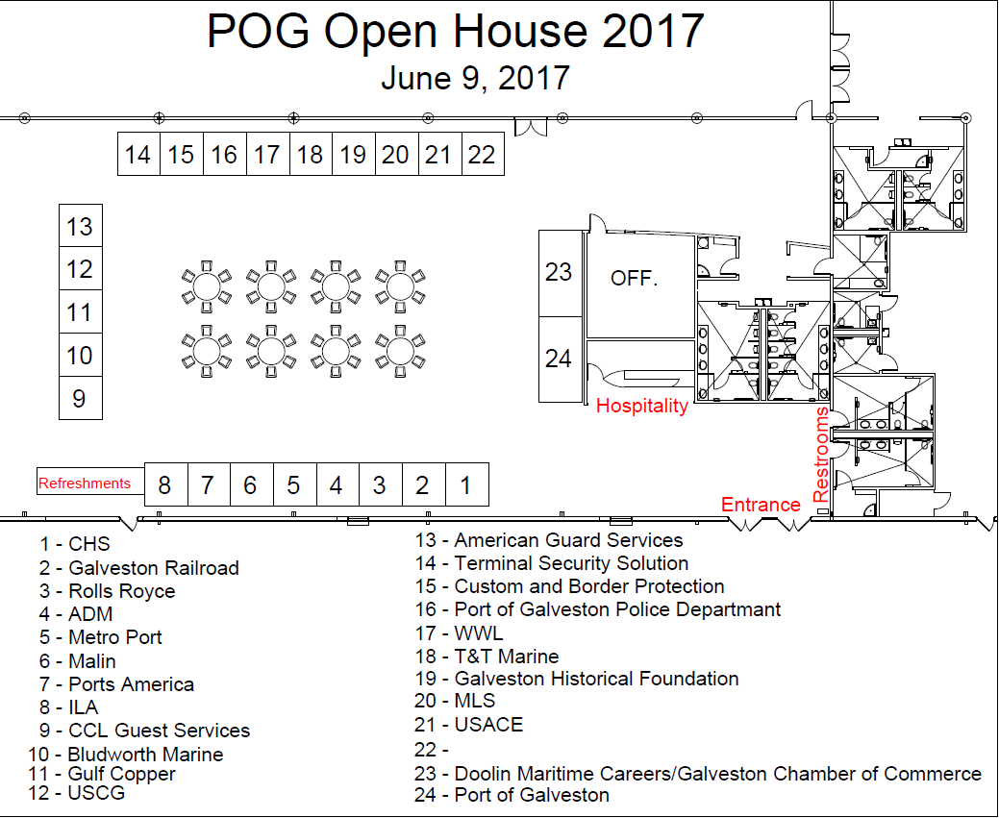
Front Back

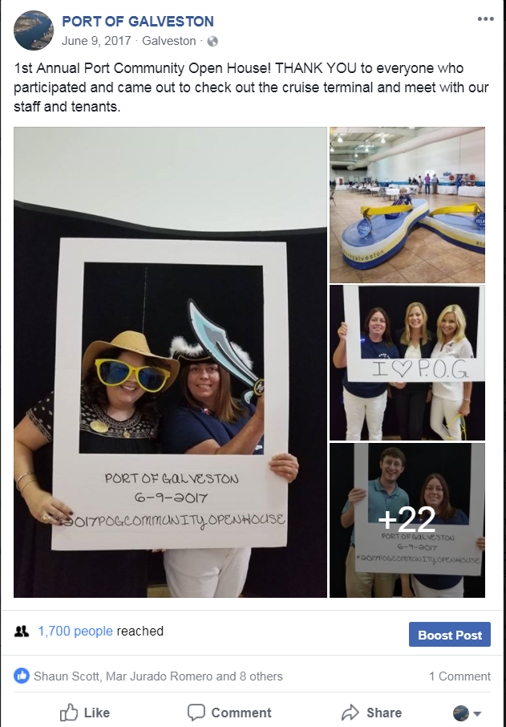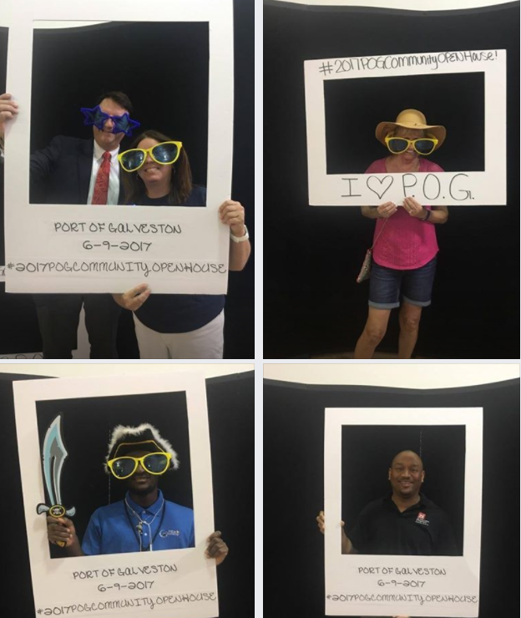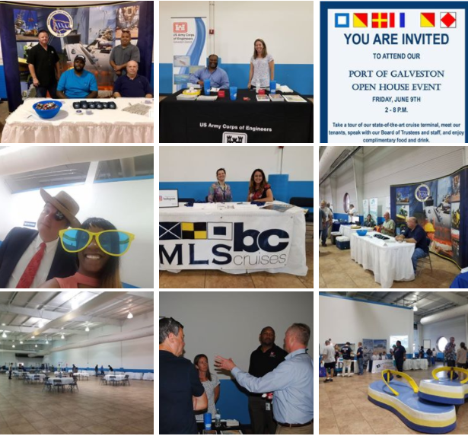
Photos on Facebook Photo Booth Booths
AREA LEADERS PRAISE PORT’S FIRST OPEN HOUSE
By MATT DEGROOD The Daily News Jun 9, 2017
The Port of Galveston’s first attempt at community awareness drew people as disparate as a representative from Texas Sen. Ted Cruz’s office and the lead firefighter for the Teichman Group.
Albert Shannon, vice chairman of the port’s governing board, recently spoke about the need for informing the community about the port and its operations.
“We need to get out and talk about what we do,” Shannon said. “We need to get the public behind us. Down the road, if we want to generate tax revenue, then we have got to get the public behind us. They need to feel good about what transpires here.”
Friday’s open house was an attempt to do just that.
“I love it and love this day,” said Gina Spagnola, president and CEO of the Galveston Regional Chamber of Commerce. “This is exactly what we need. It’s a good opportunity to have all of the vendors out here and have families asking all sorts of questions about them.”
Local officials praised the event, especially the turnout, and said it was needed to raise awareness in a community that might not know much about the port.
“A lot of the maritime industry is under appreciated,” said Jeff Sjostrom, president of the Galveston Economic Development Partnership. “There’s a lack of understanding and comprehension about the maritime industry’s role in the local and regional economy.”
Sjostrom cited an economic assessment conducted by Martin Associates that showed the maritime industry accounted for 20 percent of the county’s jobs as evidence of the impact.
Port and other local officials just need to continue to market the industry, Sjostrom said.
“The challenge is for us all to be more cognizant of how to market the town and the economic engine of the maritime industry,” he said.
Shannon said that the first open house was what he pictured when stressing the importance of community relations.
“It is exactly what I wanted,” he said. “I really hope some people are coming here looking for employment. I think people think of the port as just the labor employed by the port, but there are many private entities involved. It’s good to see folks intermingling.”
Events like the open house are important for the vendors and private entities at the port because many people don’t even know about businesses operating here, said Rick Francis, lead firefighter for the Teichman Group.
“People don’t realize we are one of the largest marine firefighting groups in the world, with offices everywhere,” Francis said. “And we are based in Galveston.”

